1. C)

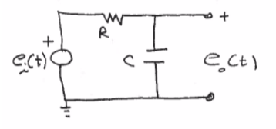Given:

Using KVL and Laplace:

Solve for transfer function between and :

Resolve the transfer function into differential equations:

D)

From data: Resistance for circuit

Sample calculation: , ,

|  |  |  |
| --- | --- | --- |
| Method | Tau Adjusted (s)* | Calculated Capacitance (nF) |
| Output 1 Initial Slope | 6.464455729936e-04 | 58.24 |
| Output 1 63.2% | 6.499970000000e-04 | 58.56 |
| Output 2 Initial Slope | 6.434486925236e-04 | 57.97 |
| Output 2 63.2% | 6.480000123426e-04 | 58.38 |
| Average |  | 58.29 |

*Adjusted Tau is the value found taken into account that the data did not start at time = 0.